|  |  |
| --- | --- |
| **Academic Year** | **: 2021-22 Sem-I** |
| **Class** | **: TY BTech Instrumentation & Control** |
| **Course Name** | **: Cyber Security** |
| **Name** | **: Shaunak Deshpande** |
| **Division** | **: IC-C** |
| **Roll No.** | **: 39** |
| **G.R. No.** | **: 11911180** |
| **Lab Number** | **: 07** |
| **Experiment** | **: Encryption Decryption** |

## Solve the following using TOOL given below:

1. Encrypt the following plain text using key k = 7.  
   Plain Text : Lord Rama was a good king.

Ans:

1. Lord Rama was a good king  
 2. Mpse sbnb xbt b hppe ljoh  
 3. Nqtf tcoc ycu c iqqf mkpi  
 4. Orug udpd zdv d jrrg nlqj  
 5. Psvh veqe aew e kssh omrk  
 6. Qtwi wfrf bfx f ltti pnsl  
 7. Ruxj xgsg cgy g muuj qotm  
 svyk yhth dhz h nvvk rpun

Encrypted text= svyk yhth dhz h nvvk rpun

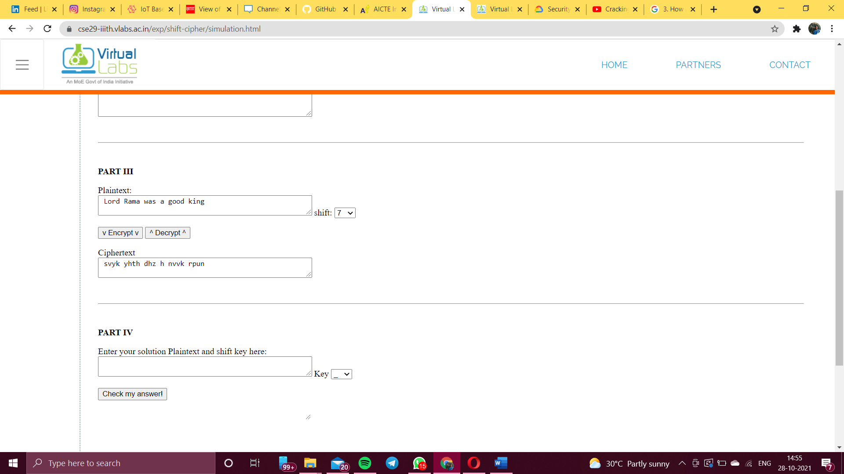

1. Given a plain text and its corresponding cipher text, find out the key used for the encryption of the plain text.  
     
   Plain Text : abcdefghijklmnopqrstuvwxyz  
   Cipher Text : TDNUCBZROHLGYVFPWIXSEKAMQJ

Ans:

1. TDNUCBZROHLGYVFPWIXSEKAMQ  
 2. u  
 3. v   
 4. w  
 5. x  
 6. y  
 7. z  
 abcdefghijklmnopqrstuvwxyz

Key = 7

1. How many different keys are possible with an n-letter alphabet?

Ans:

The number of symbols in key is n=26 with 26 possible symbol..then

1. Given a cipher text, find out the corresponding plain text using brute force attack.  
   Cipher text : HAAHJR HA KHDU

Ans:

HAAHJR HA KHDU  
 gzzgiq   
 fyyfhp   
 exxego   
 dwwdfn   
 cvvcem   
 buubdl   
 attack at dawn

Plain text= attack at dawn

